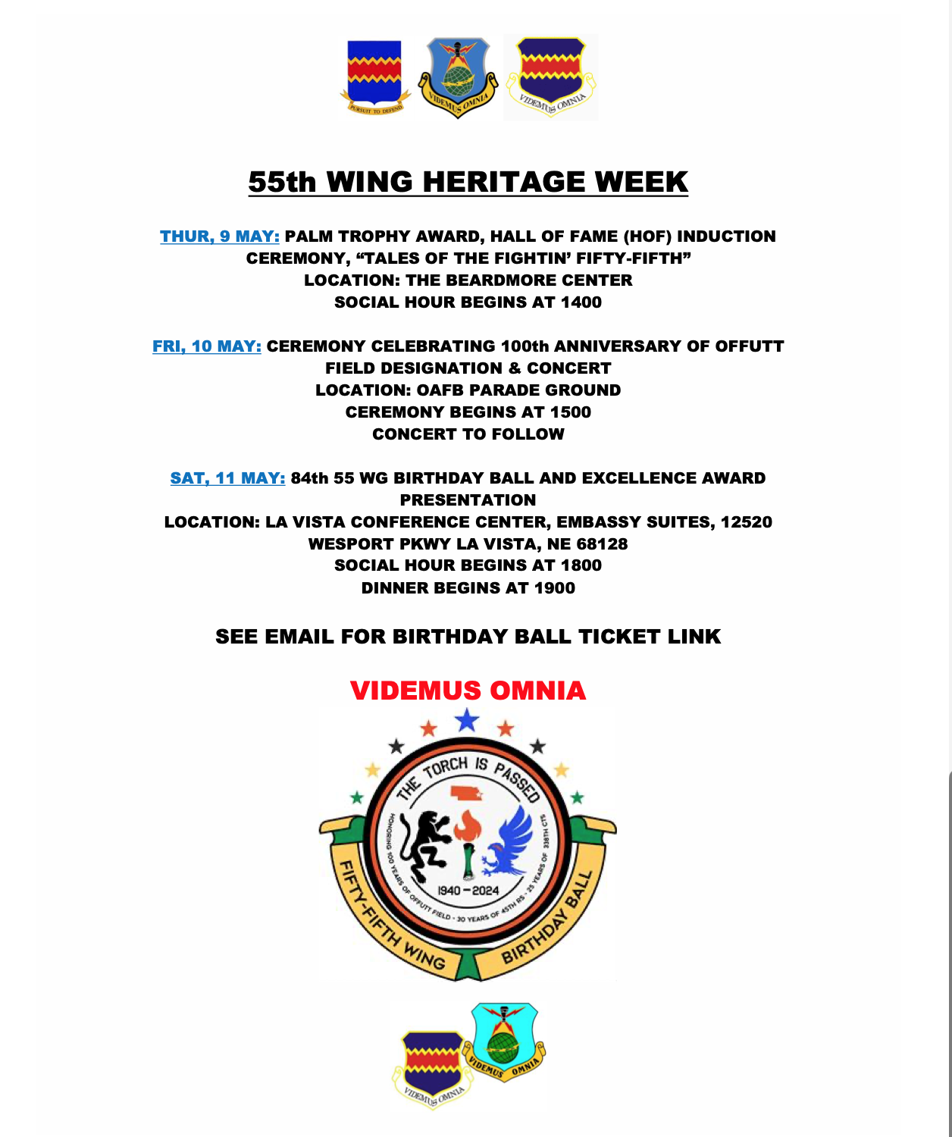

Tickets are $55 each and available at the link below. Must be purchased by 3 May 2024.

Tickets: https://einvitations.afit.edu/inv/anim.cfm?i=853521&k=0A64410C7956
Attire: Mess Dress/Semi-Formal, Tuxedo/Coat & Tie, Formal Dress/Evening Gown

Overnight Rooms Available: The Courtyard Omaha LaVista, located next door to the La Vista Conference Center, is offering $108 (plus tax) rooms/night with complimentary breakfast Thursday, 9 May 2024 – Sunday, 12 May 2024.
Rooms are available for purchase at the block rate until 30 April 2024. To reserve, use the following link to the online reservation or call +1 402-331-7400 and state that you are with the 55th Wing Association. 55th Wing Association Room Block

